Amazon Web Services

Overview:

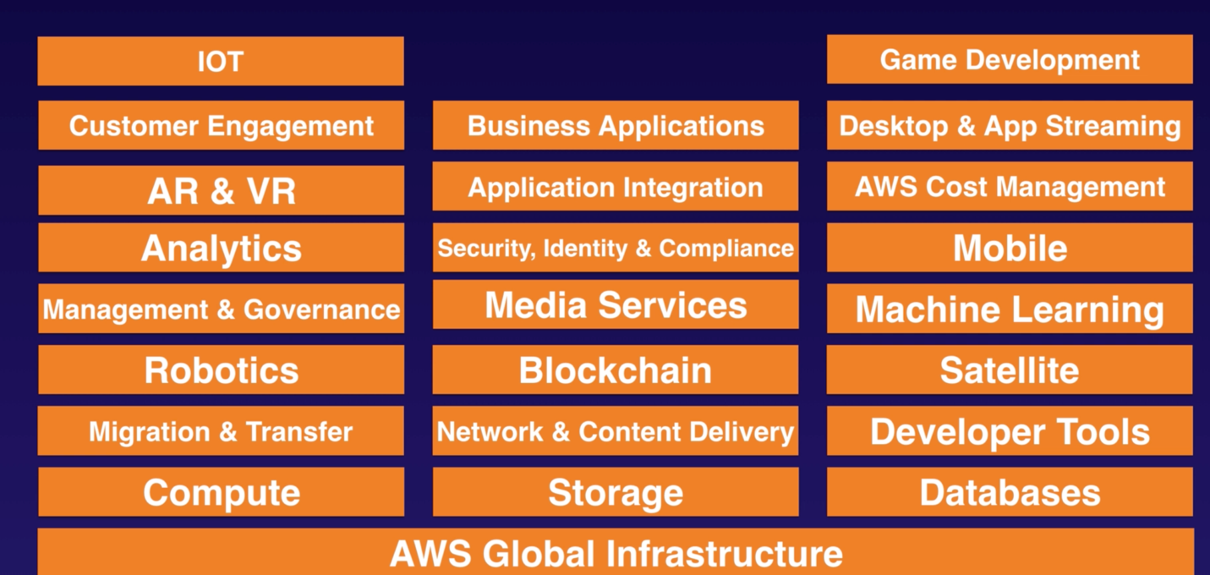

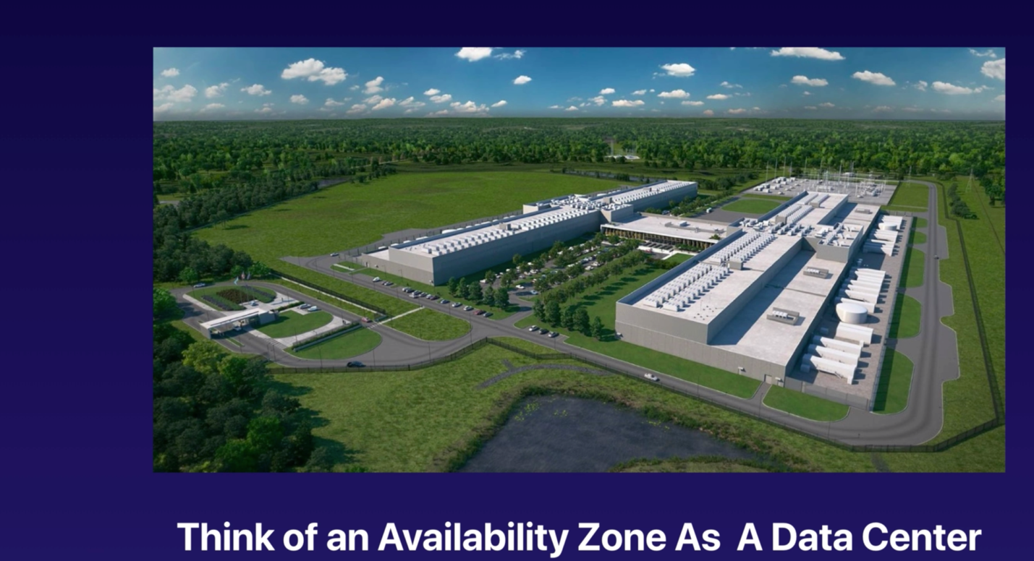

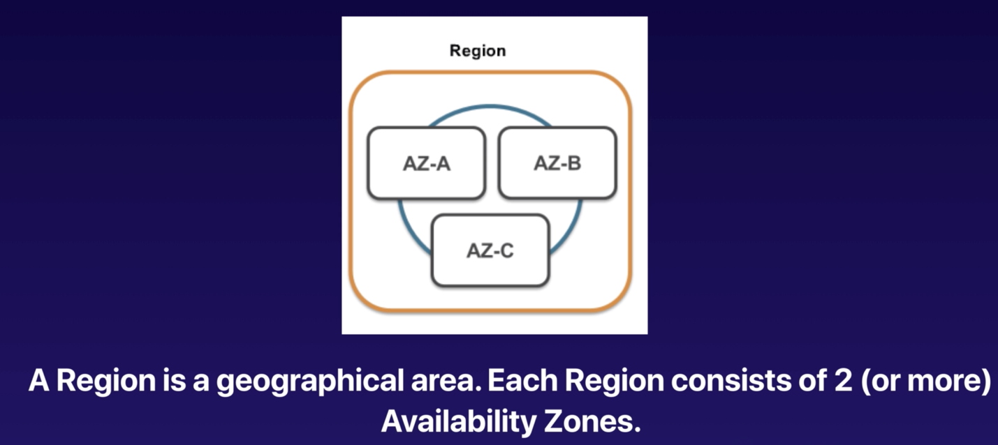

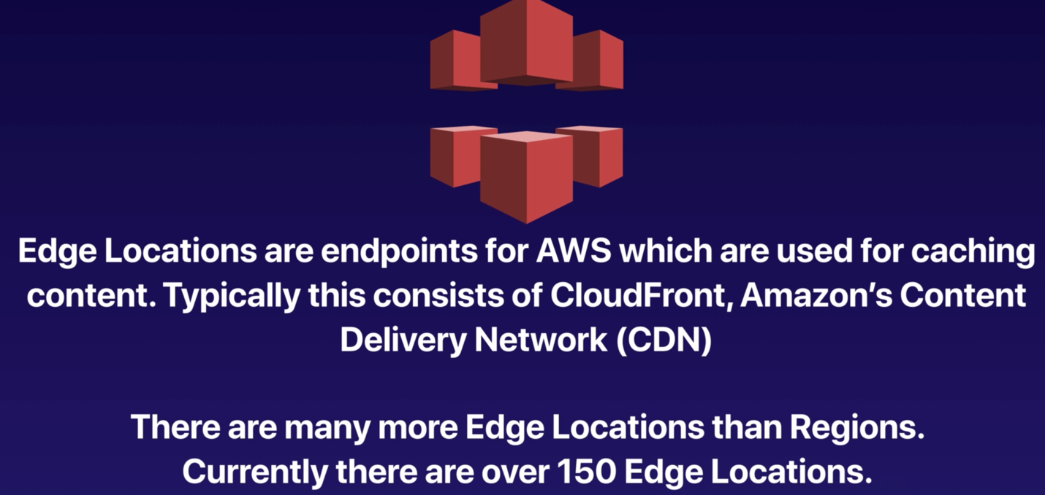

No of Edge Locations > No of Availability Zones > No of regions.

IAM (Identity and Access Management):

IAM allows users to manage users and level of access to the aws console. IAM is not restricted to individual regions. You can use the IAM User credentials to login to the account from anywhere in the world.

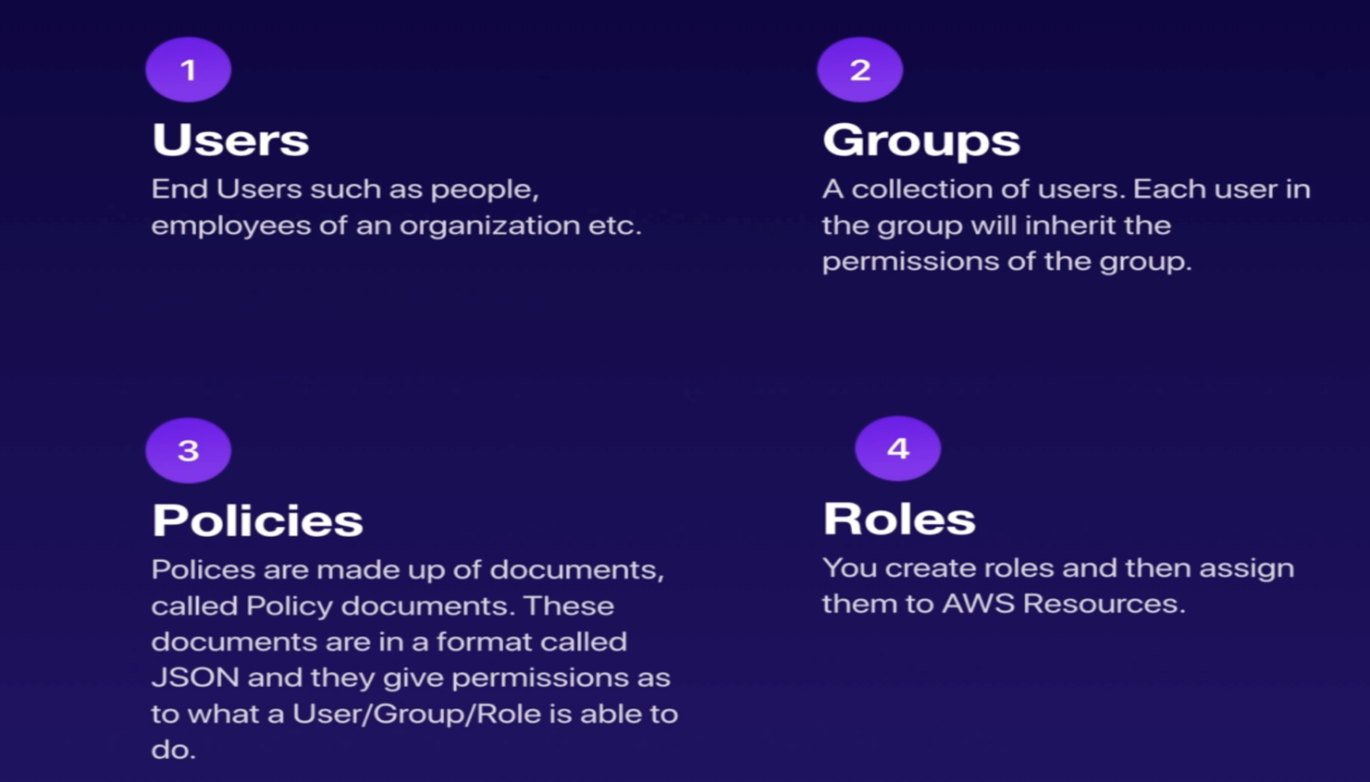

SUMMARY:

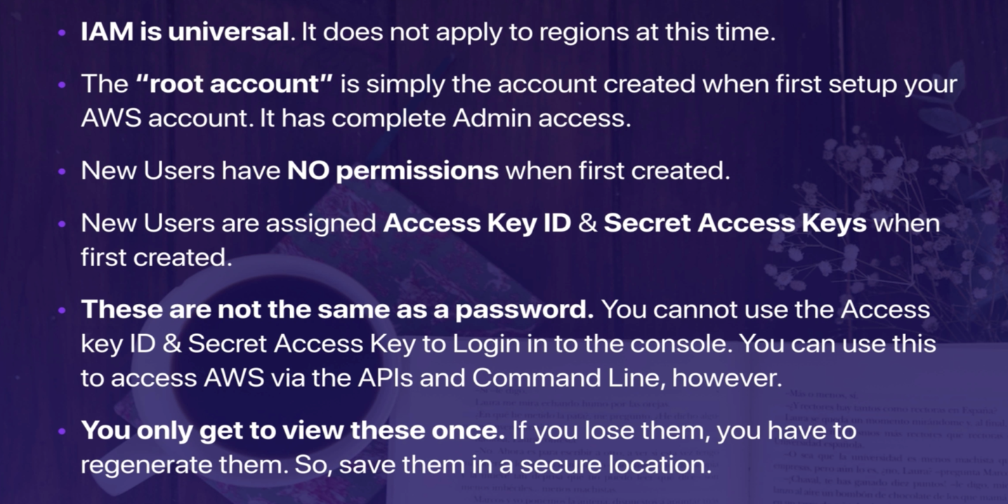

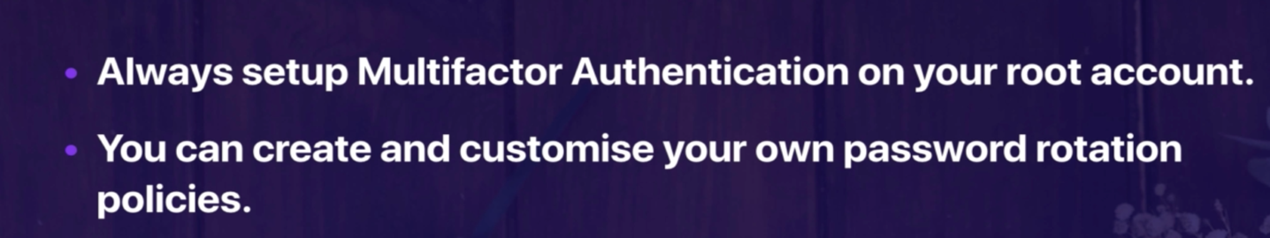

IAM DEMO:

* Account Alias
* Multifactor Authentication
* Create a User, Group.
* Assign a policy to the group.
* IAM Password rotation policy.
* Login using the created user.
* Make Credentials inactive.
* Delete Users and groups.
* Create a Role.

S3(Simple Storage Service):

S3 is used to store files (Object based Storage). Objects are stored in buckets. Name of the bucket should be universal. URL: <https://S3-eu-west-1.amazon.com/bucketname>. When the files are uploaded properly then we will receive a HTTP 200 Code.

* Object consists of KEY, Value, Version ID, Metadata.
* Data consistency: Read after write for puts of new objects, Eventual consistency for override PUTS and DELETES.

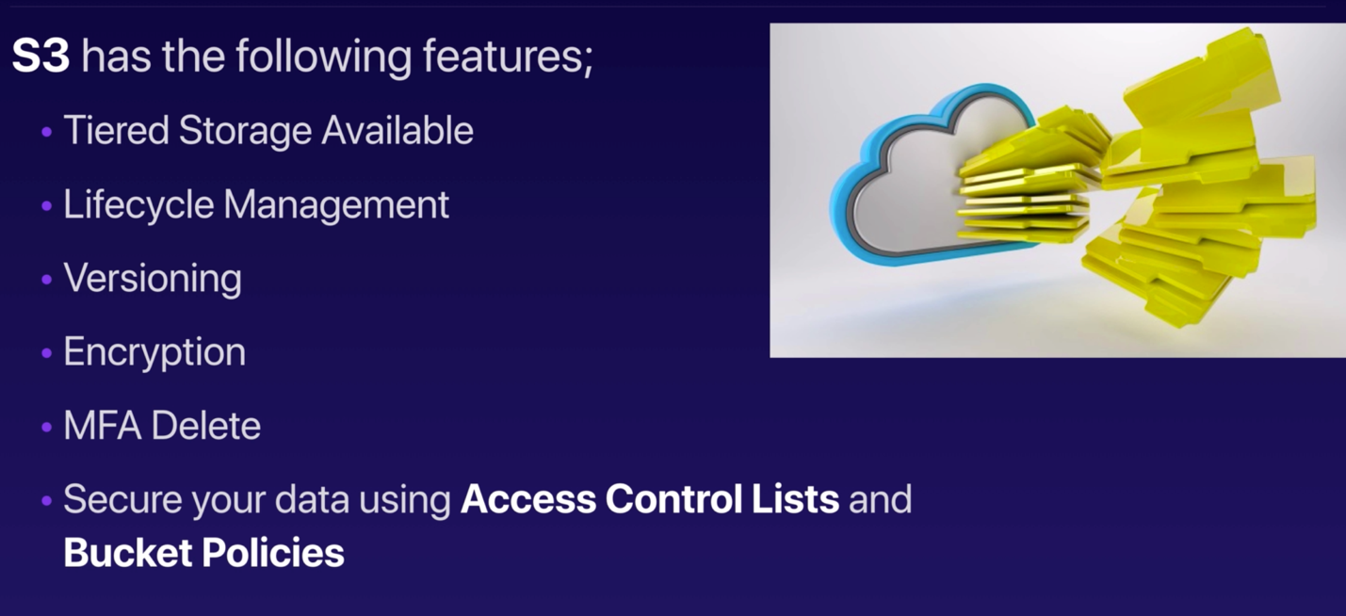

Different Storage Classes:

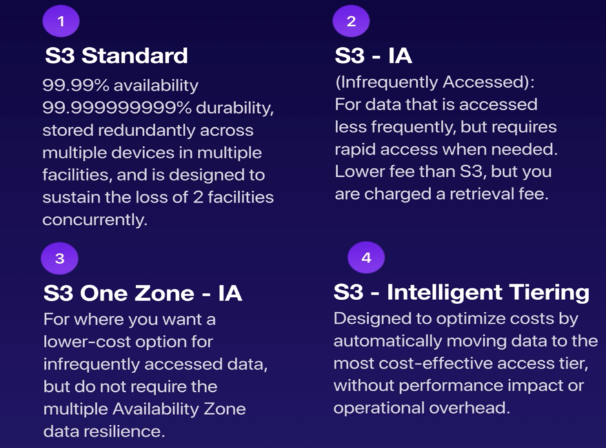

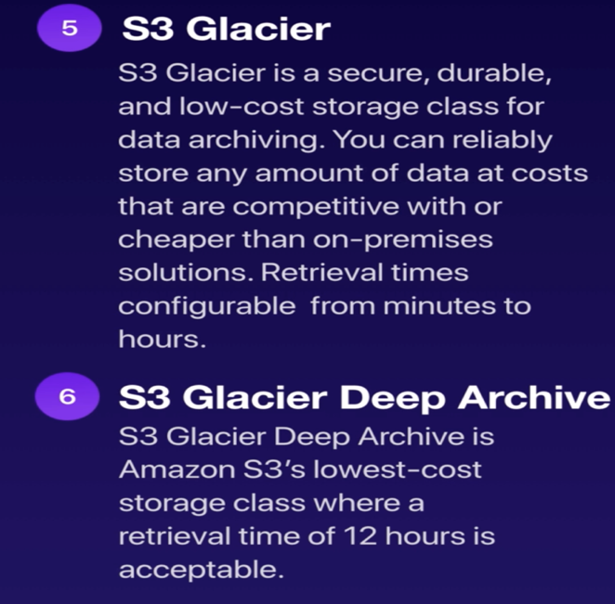

Cross Region Replication:

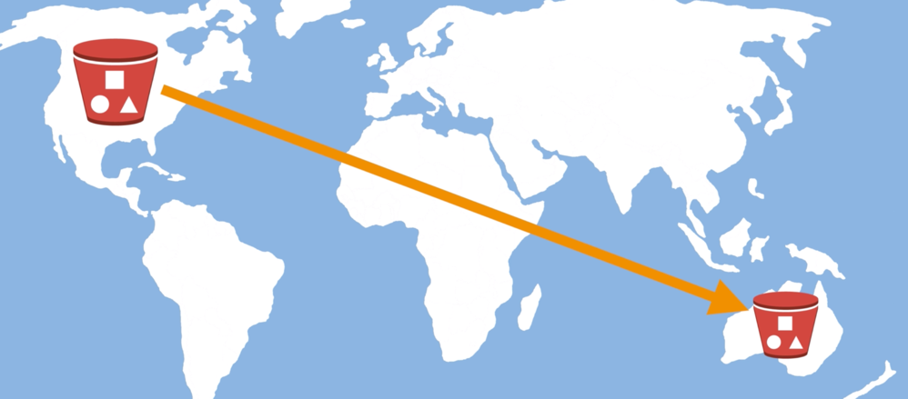

Transfer Acceleration:

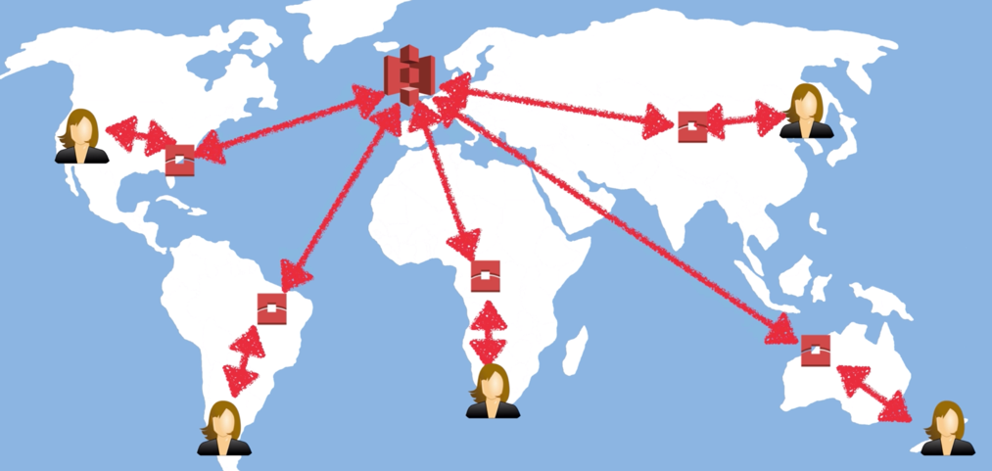

Encryption of Objects:

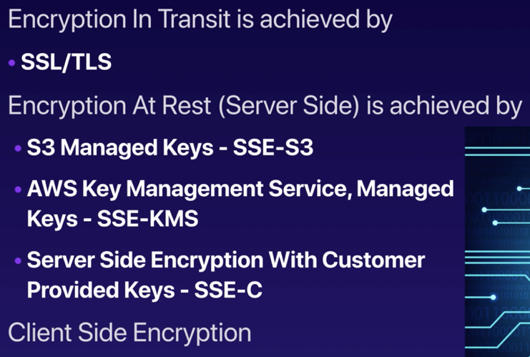

DEMO:

* On bucket creation, Versioning, Cross Region Replication, Encryption of objects in S3 bucket.

CLOUDFRONT:

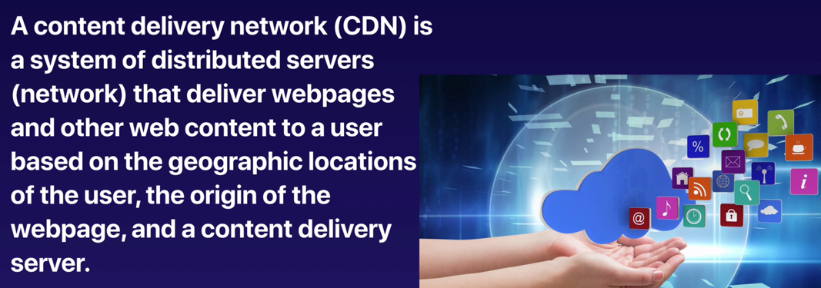

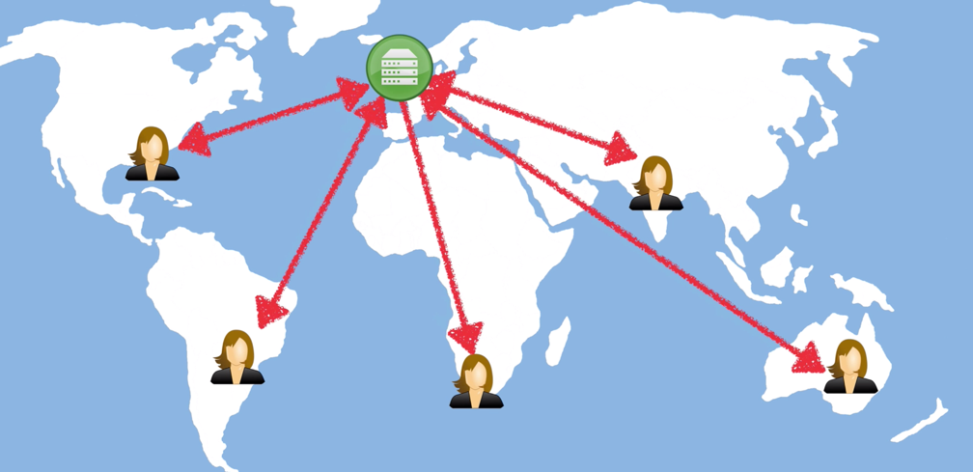

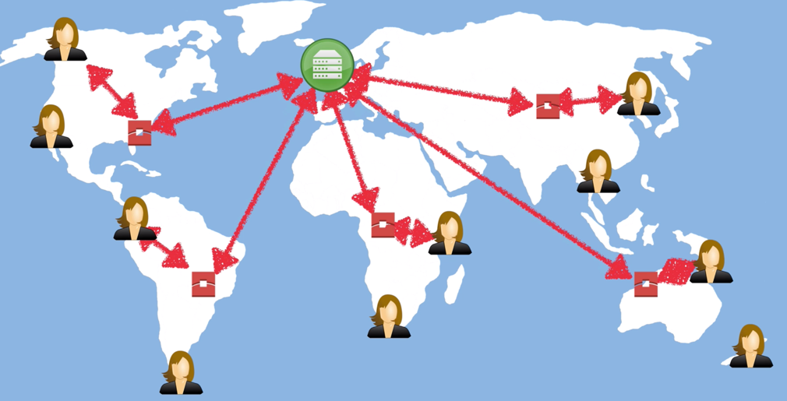

TYPES OF DISTRIBUTIONS:

* Web Distribution for websites.
* RTMP Distribution for media streaming.

SNOWBALL:

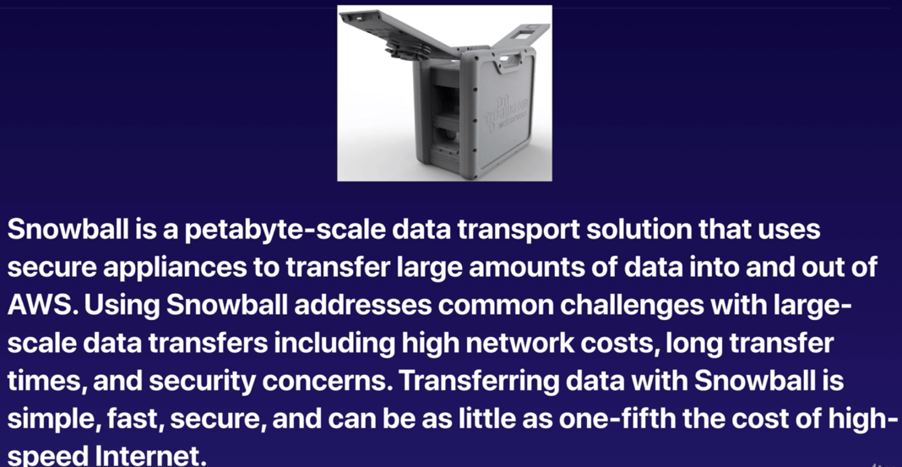

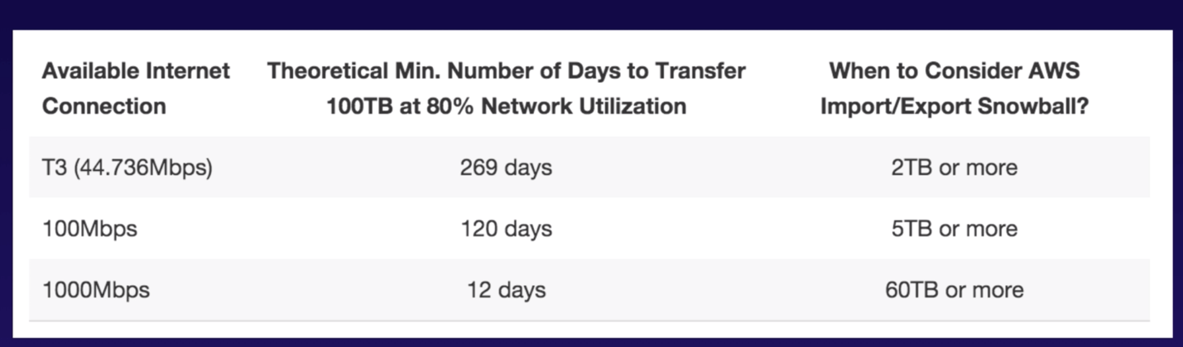

STORAGE GATEWAYS:

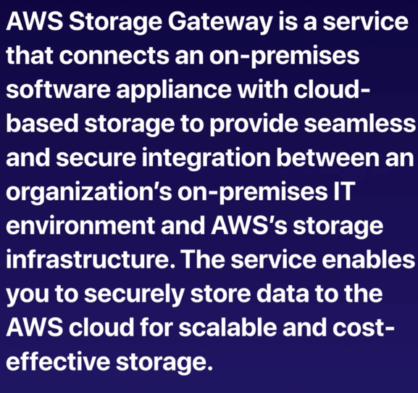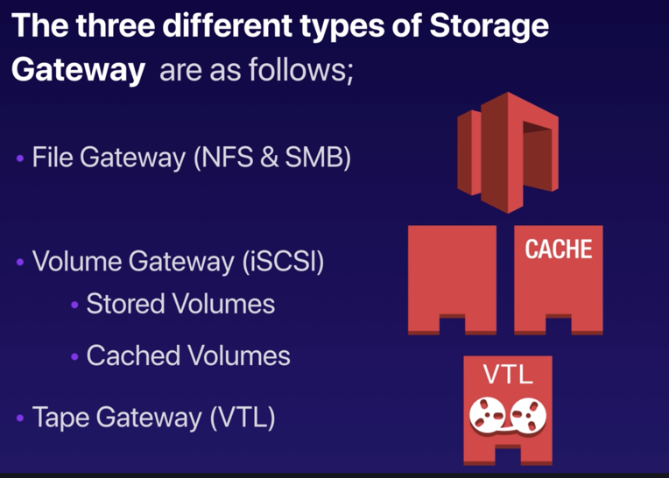

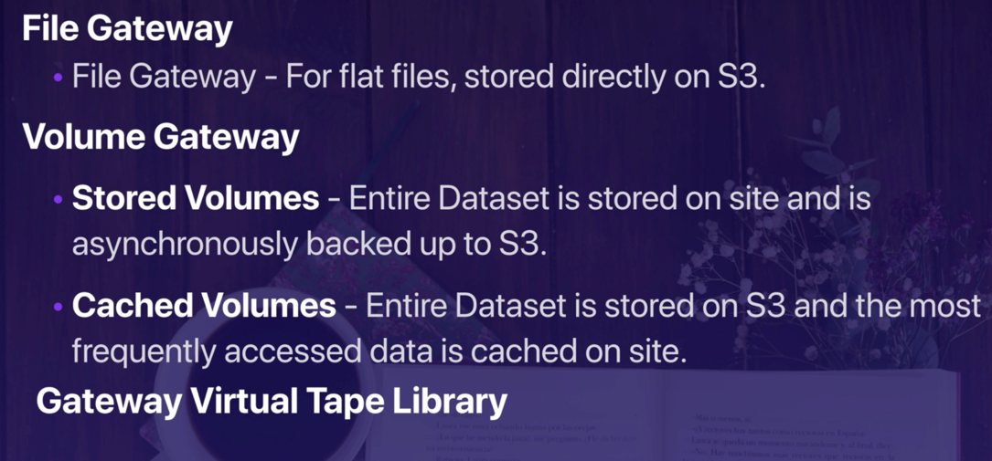

EC2 Instances:

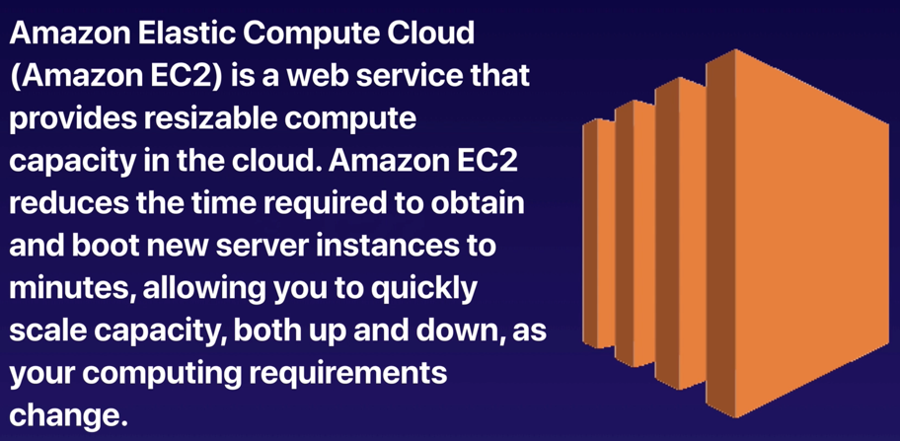

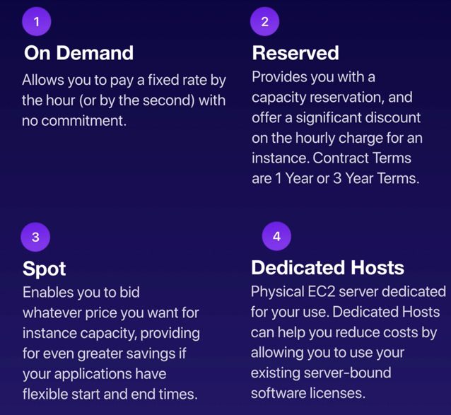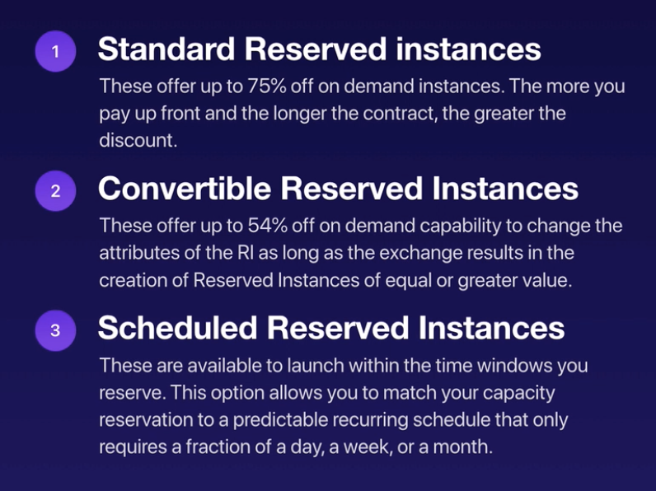

TYPES OF EC2 INSTANCES:

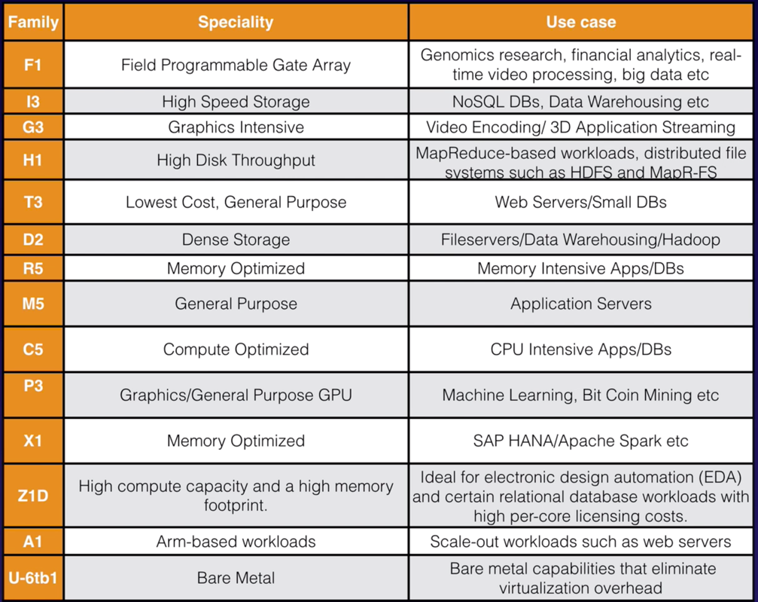

* Launch instance and download the key pair for a particular region.

Shell commands: mkdir SSH, mv keypair SSH, **chmod 400 LunchAndLearnAvinashNorthVirginia.pem,** ssh ec2-user@52.91.234.160 -i LunchAndLearnAvinashNorthVirginia.pem

Scripts to convert as a Web Server:

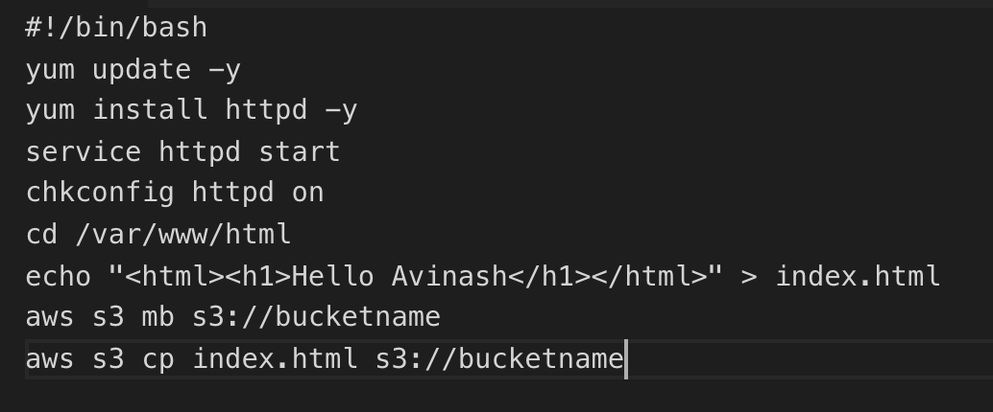

SECURITY GROUPS:

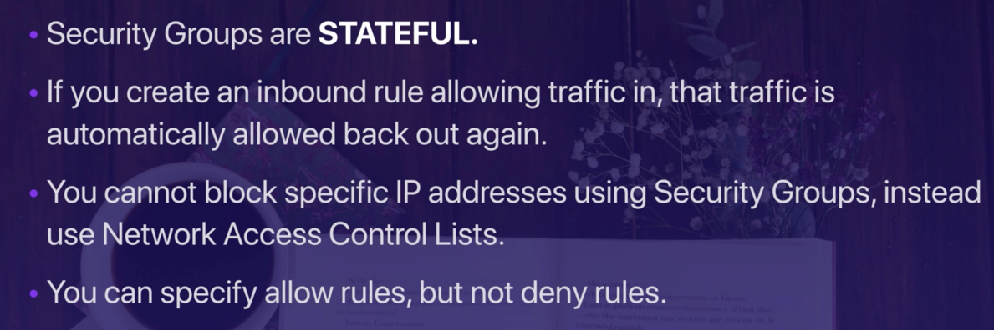

ELASTIC BLOCK STORE:

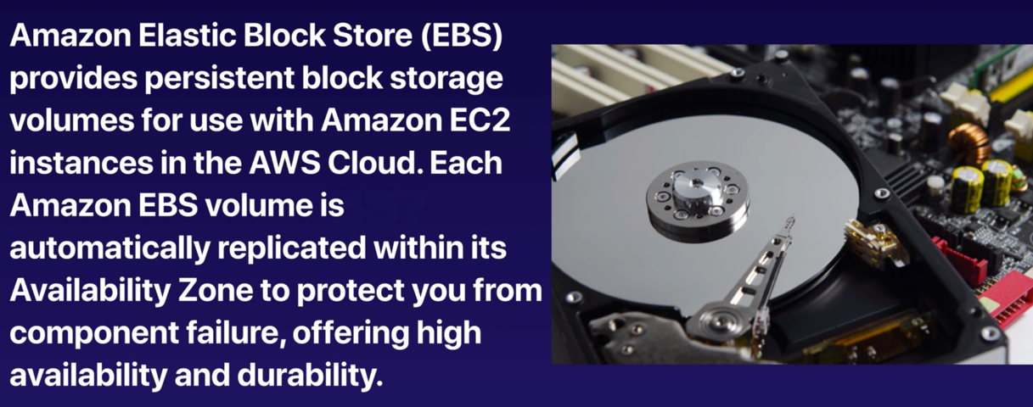

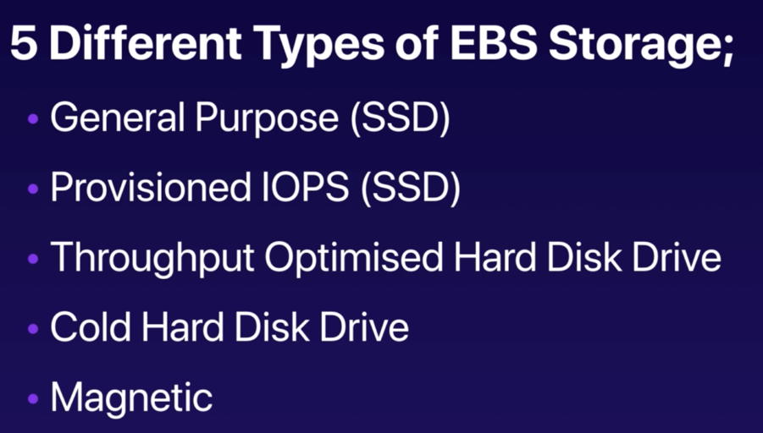

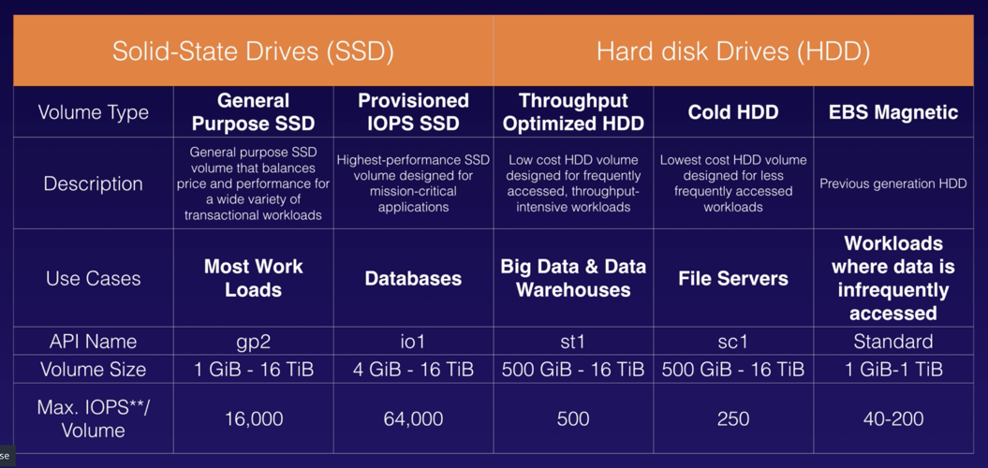

How to Move an Instance from One Availability Zone to Another?

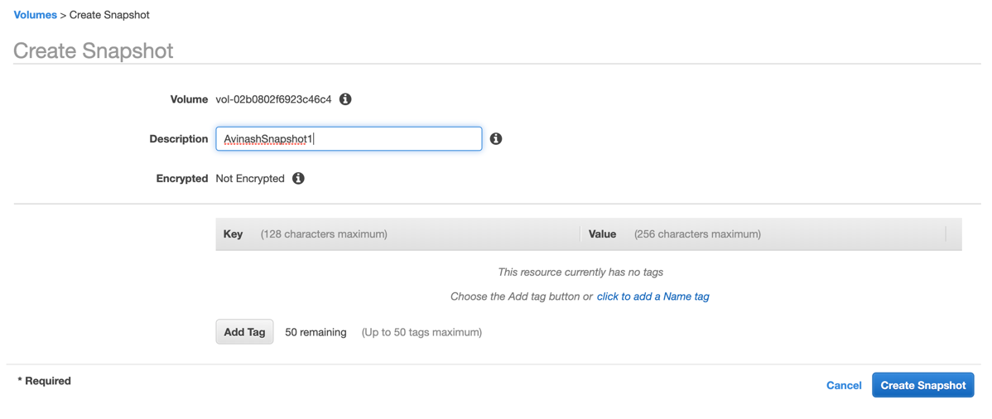

----> Create a snapshot from the root device volume, from the snapshot create an image and launch the image into the new availability zone.

How do we move the image to a new Region??

----> Copy the AMI into new region and launch the image.

How do we encrypt the root device volume??

----> After creating snapshot of unencrypted volume, copy the snapshot as an encrypted snapshot and create an AMI and launch the instance.

CLOUDWATCH:

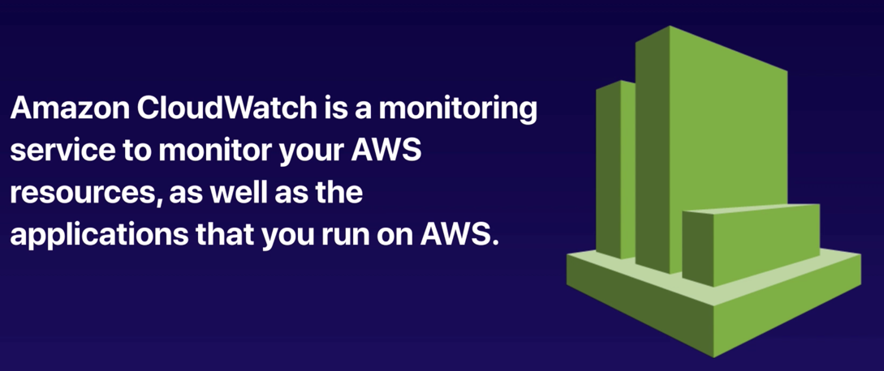

CLOUDTRIAL:

